**VISVESVARAYA TECHNOLOGICAL UNIVERSITY**

**“JnanaSangama”, Belgaum -590014, Karnataka.**



**LAB RECORD**

**Computer Networks Laboratory (23CS5PCCON)**

***Submitted by***

**Kedar Sainath Joshi (1BM22CS126)**

***in partial fulfillment for the award of the degree of***

**BACHELOR OF ENGINEERING**

***in***

**COMPUTER SCIENCE AND ENGINEERING**



**B.M.S. COLLEGE OF ENGINEERING**

**(Autonomous Institution under VTU)**

**BENGALURU - 560019**

**Academic Year 2024 - 25 (odd)**

**B.M.S. College of Engineering  
Bull Temple Road, Bangalore 560019**(Affiliated To Visvesvaraya Technological University, Belgaum)

**Department of Computer Science and Engineering**



**CERTIFICATE**

This is to certify that the Lab work entitled “Computer Networks (23CS5PCCON)” carried out by **Kedar Sainath Joshi (1BM22CS126),** who is bonafide student of **B.M.S. College of Engineering.** It is in partial fulfilment for the award of **Bachelor of Engineering in Computer Science and Engineering** of the Visvesvaraya Technological University, Belgaum. The Laboratory report has been approved as it satisfies the academic requirements of the above-mentioned subject and the work prescribed for the said degree.

|  |  |
| --- | --- |
| Rajeshwari Madli  Assistant Professor  Department of CSE, BMSCE | Dr. Kavitha Sooda  Professor & HOD  Department of CSE, BMSCE |

**INDEX**

|  |  |  |  |
| --- | --- | --- | --- |
| **Sl.**  **No.** | **Date** | **Experiment Title** | **Page No.** |
| 1 | 01.10.24 | Laboratory Program – 1 (Topology Simulation) | 1 |
| 2 | 08.10.24 | Laboratory Program – 2 (Router IP Configuration) | 5 |
| 3 | 08.10.24 | Laboratory Program – 3 (Routing Configuration) | 8 |
| 4 | 22.10.24 | Laboratory Program – 4 (Default and Static Configuration) | 11 |
| 5 | 29.10.24 | Laboratory Program – 5 (TELNET Access) | 16 |
| 6 | 29.10.24 | Laboratory Program – 6 (TTL Demonstration) | 18 |
| 7 | 12.11.24 | Laboratory Program – 7(A) (DHCP Configuration within the same LAN) | 22 |
| 8 | 12.11.24 | Laboratory Program – 7(B) (DHCP Configuration outside the LAN) | 25 |
| 9 | 12.11.24 | Laboratory Program – 8 (Web Server & DNS) | 28 |
| 10 | 19.11.24 | Laboratory Program – 9 (RIP Routing Setup) | 30 |
| 11 | 26.11.24 | Laboratory Program – 10 (WLAN Setup | 33 |
| 12 | 26.11.24 | Laboratory Program – 11 (ARP in LAN) | 36 |
| 13 | 3.12.24 | Laboratory Program – 12 (VLAN Configuration) | 40 |
| 14 | 3.12.24 | Laboratory Program – 13 (CRC Error Detection) | 44 |
| 15 | 17.12.24 | Laboratory Program – 14 (Leaky Bucket Algorithm) | 48 |
| 16 | 24.12.24 | Laboratory Program – 15(A) (TCP Client-Server) | 50 |
| 17 | 24.12.24 | Laboratory Program – 15(B) (UDP Client-Server) | 52 |

Github Link: https://github.com/kedar-357/Computer-Networks

**LABORATORY PROGRAM – 1**

Create a topology and simulate sending a simple PDU from source to destination using hub and switch as connecting devices and demonstrate ping message.

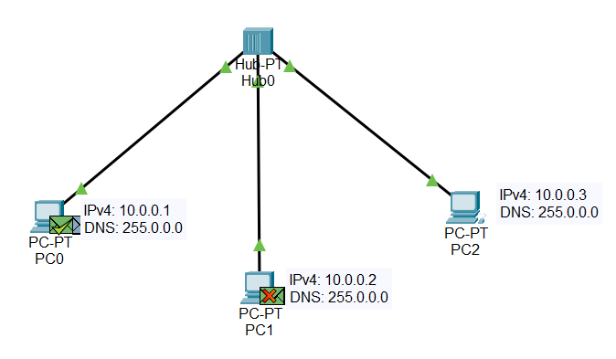



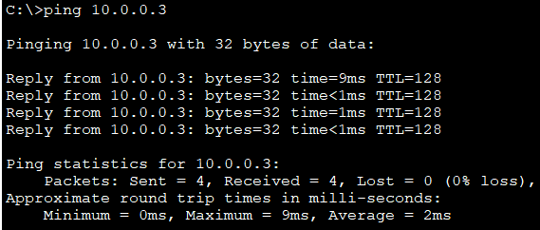

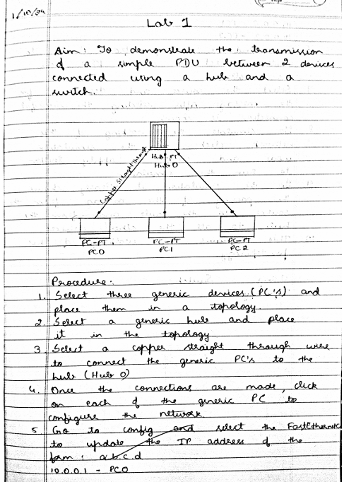

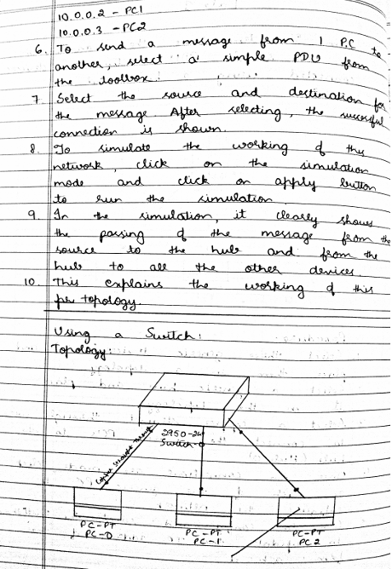

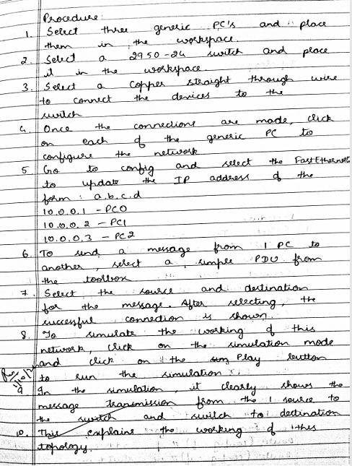

**LABORATORY PROGRAM – 2**

Configure IP address to routers in packet tracer. Explore the following messages: ping responses, destination unreachable, request timed out, reply.

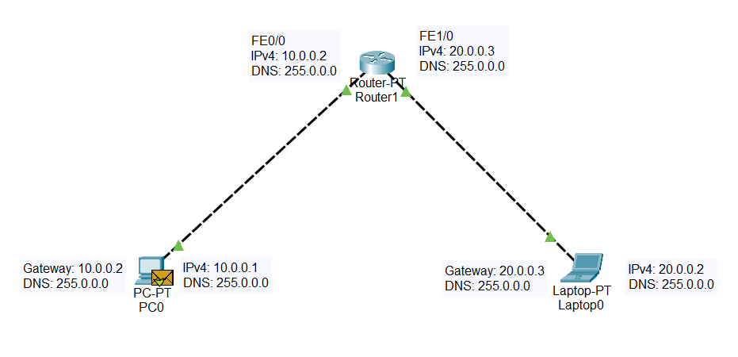

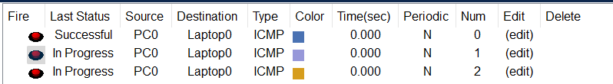

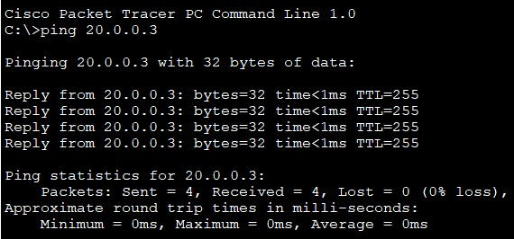

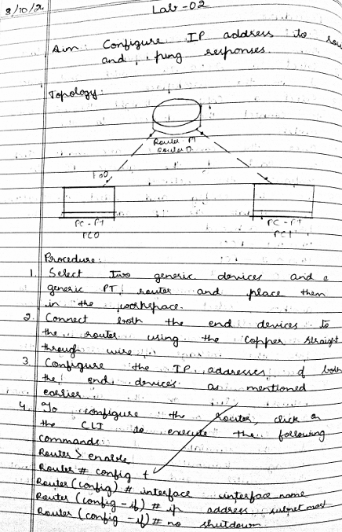

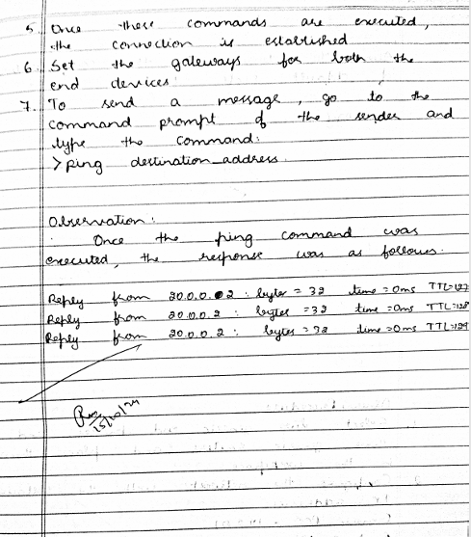

**LABORATORY PROGRAM – 3**

Configure static route to the Router.

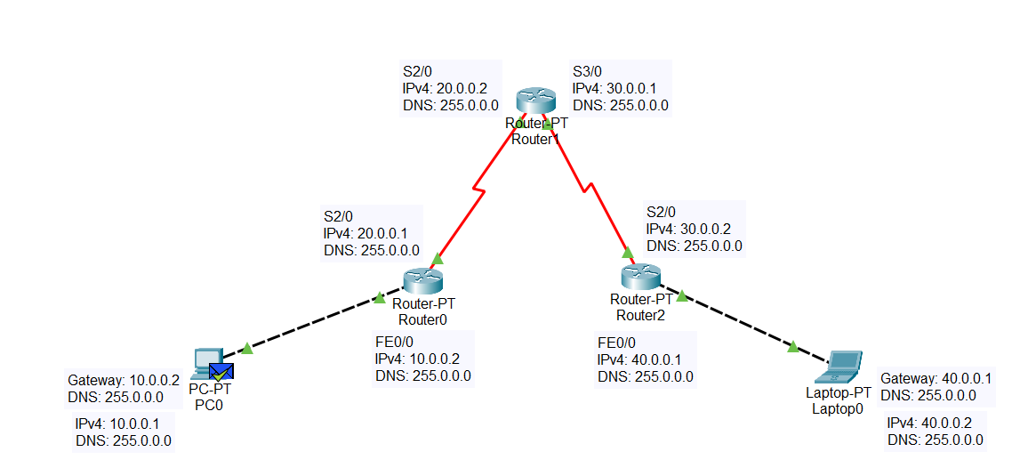

*SHOW IP ROUTE*

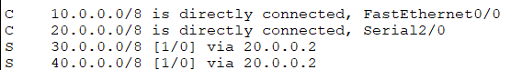

Figure 3.1: Router0

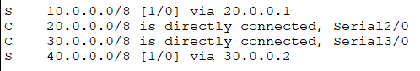

Figure 3.2: Router1

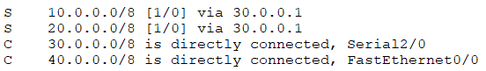

Figure 3.3: Router3.3

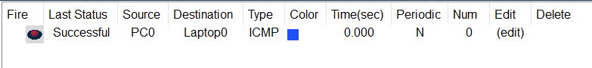

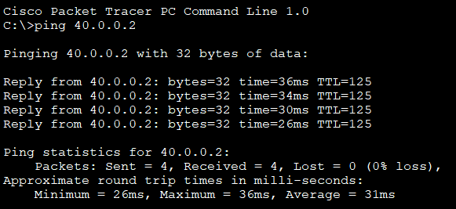

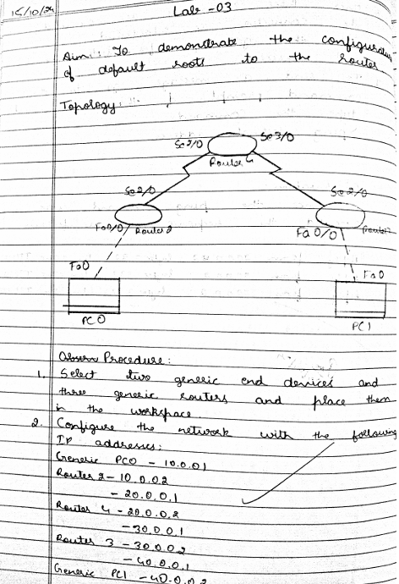

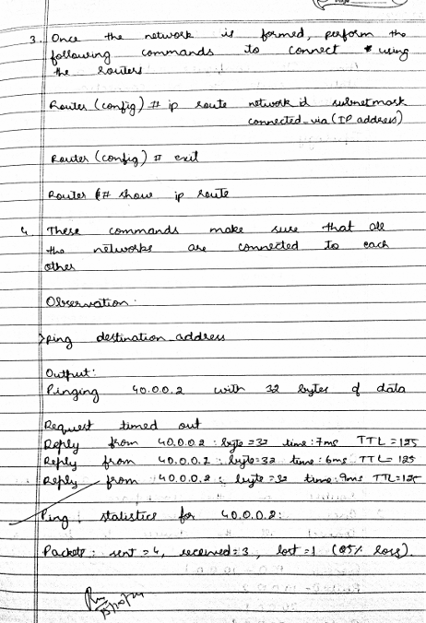

**LABORATORY PROGRAM – 4(A)**

Configure default route, static route to the Router.

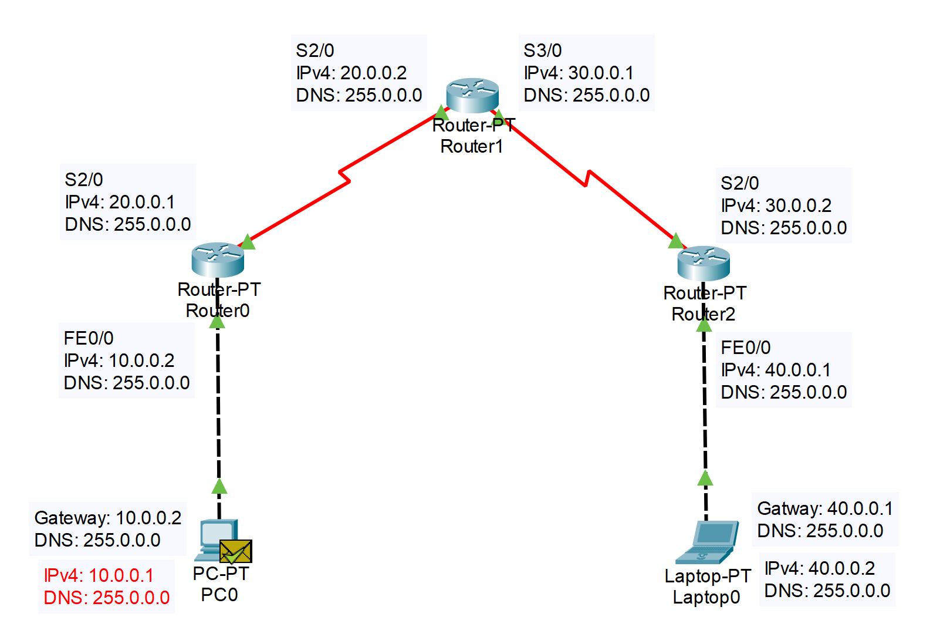

*SHOW IP ROUTE*

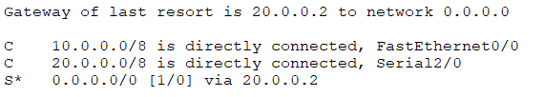

Figure 4.1: Router0

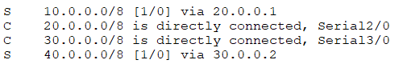

Figure4.2: Router1

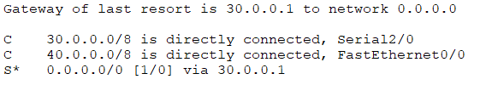

Figure 4.3: Router2



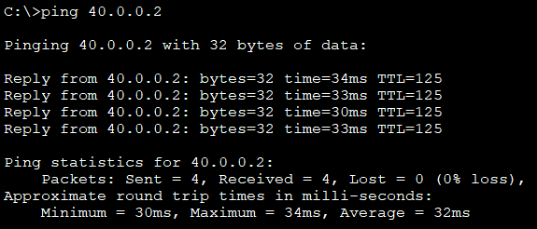

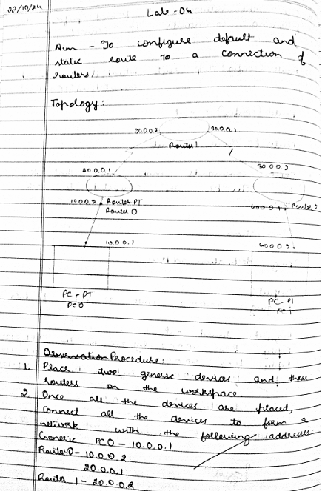

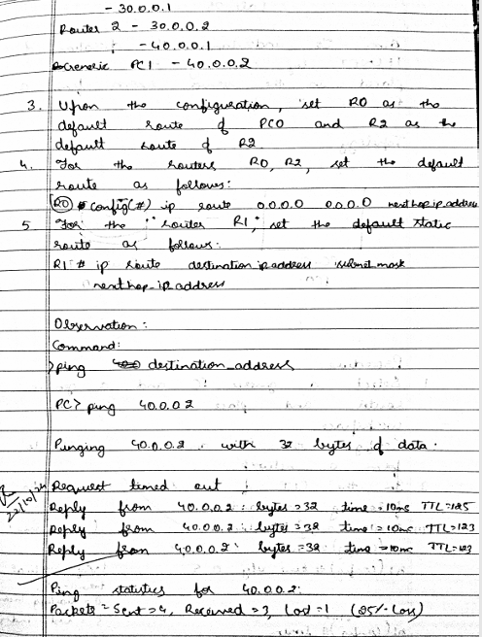

**LABORATORY PROGRAM – 4(B)**

Configure default route, static route to the Router, inclusive switches.

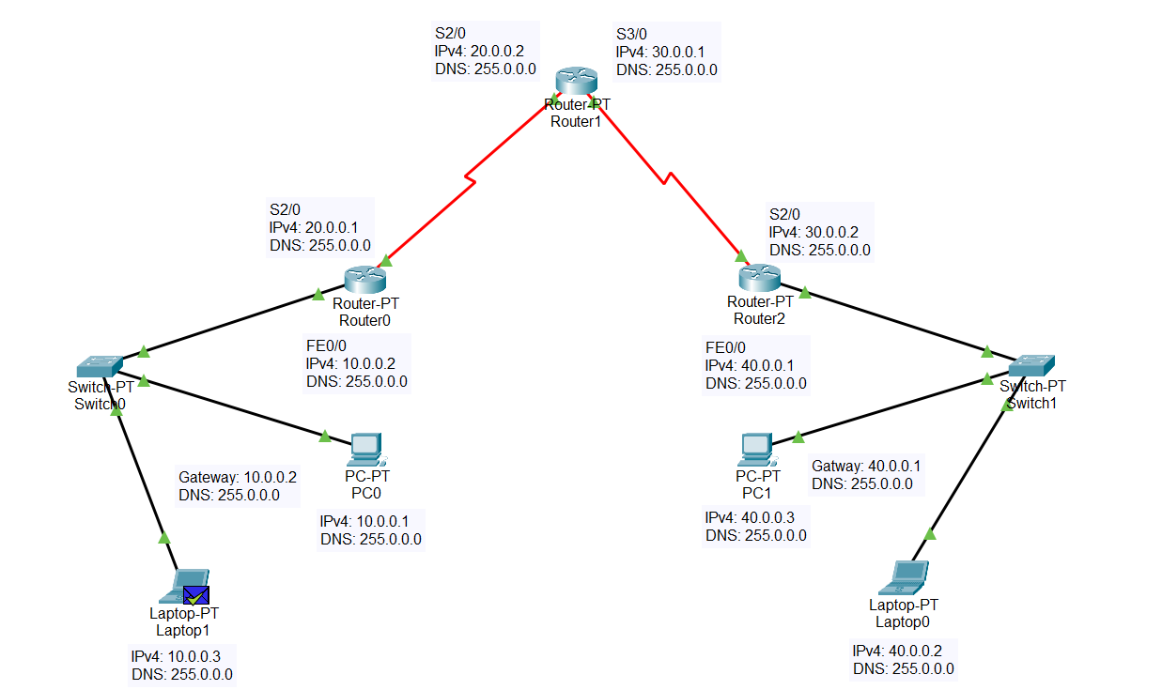

*SHOW IP ROUTE*



Figure 4.1: Router0



Figure4.2: Router1



Figure 4.3: Router2



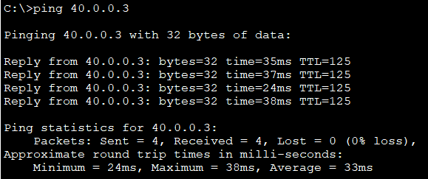

**LABORATORY PROGRAM – 5**

To understand the operation of TELNET by accessing the router in server room from a PC in IT office.

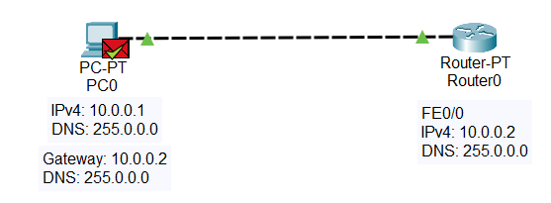

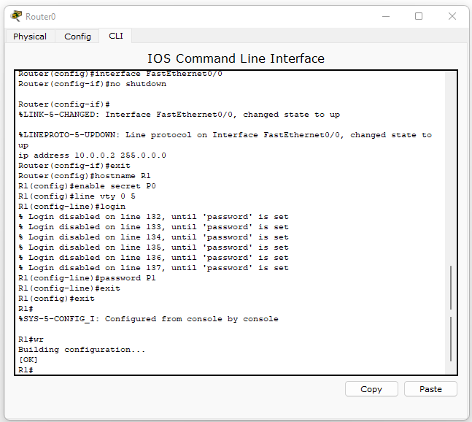



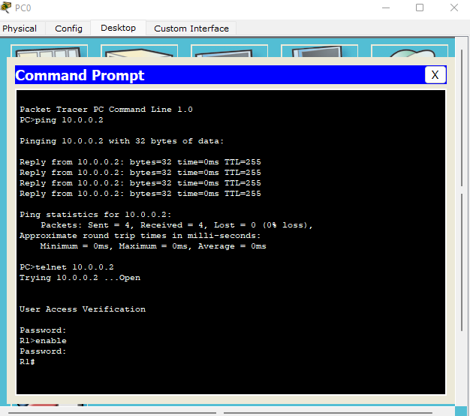

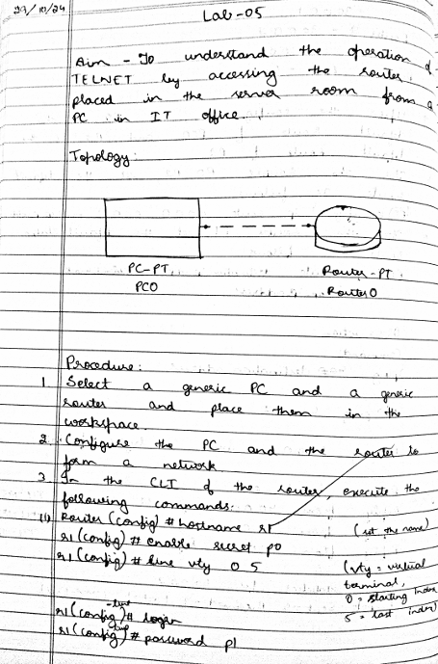

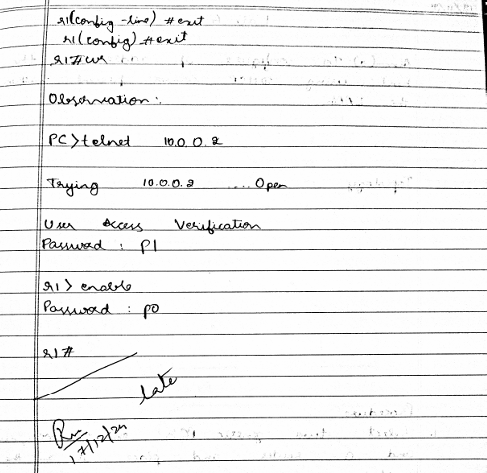

**LABORATORY PROGRAM – 6**

Demonstrate the TTL/ Life of a Packet.

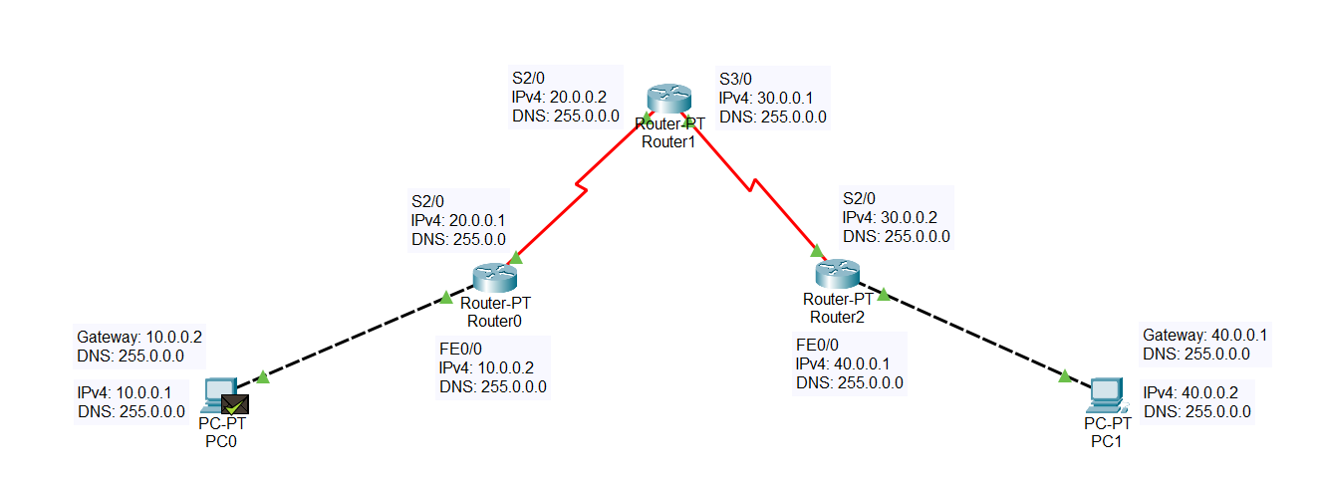

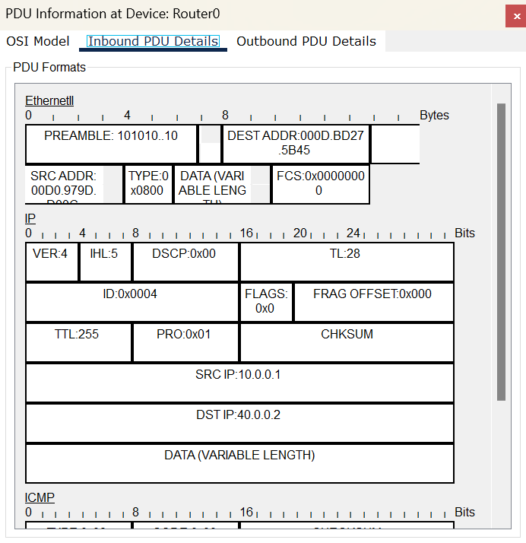

Figure 6.1: Inbound PDU, Router0

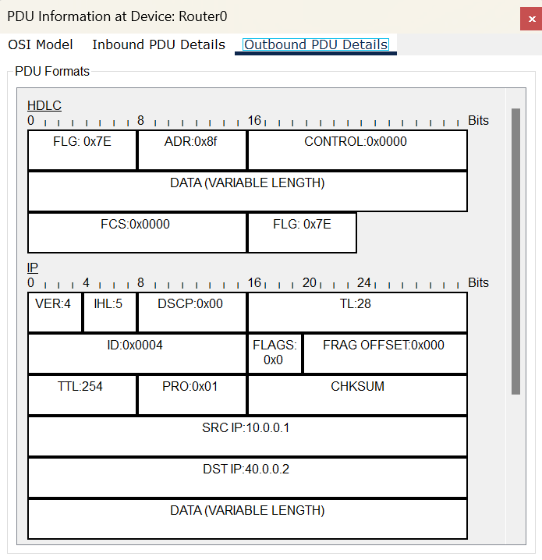

Figure 6.2: Outbound PDU, Router0

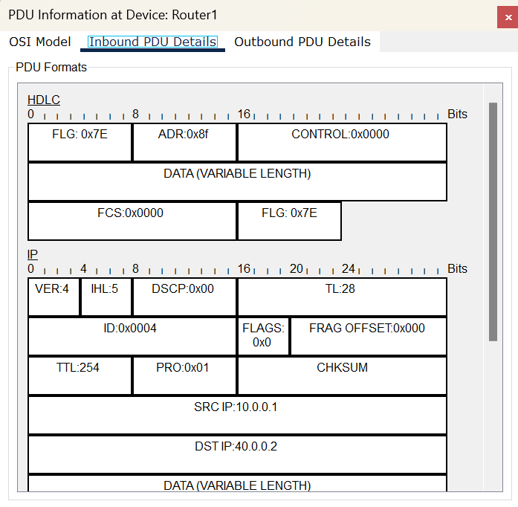

Figure 6.3: Inbound PDU, Router1

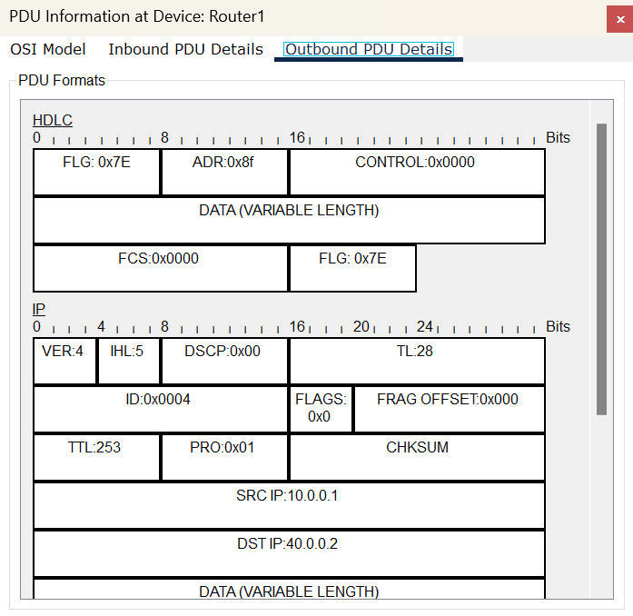

Figure 6.4: Outbound PDU, Router1

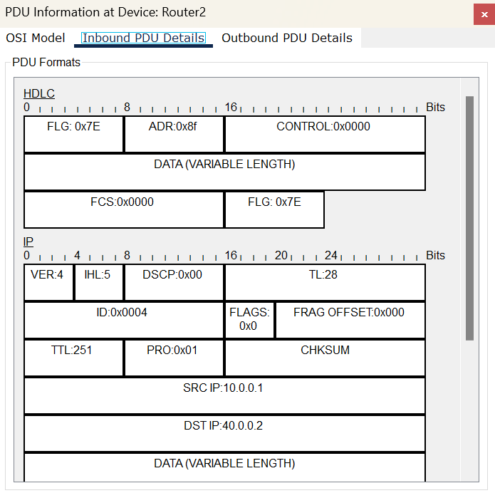

Figure 6.5: Inbound PDU, Router2

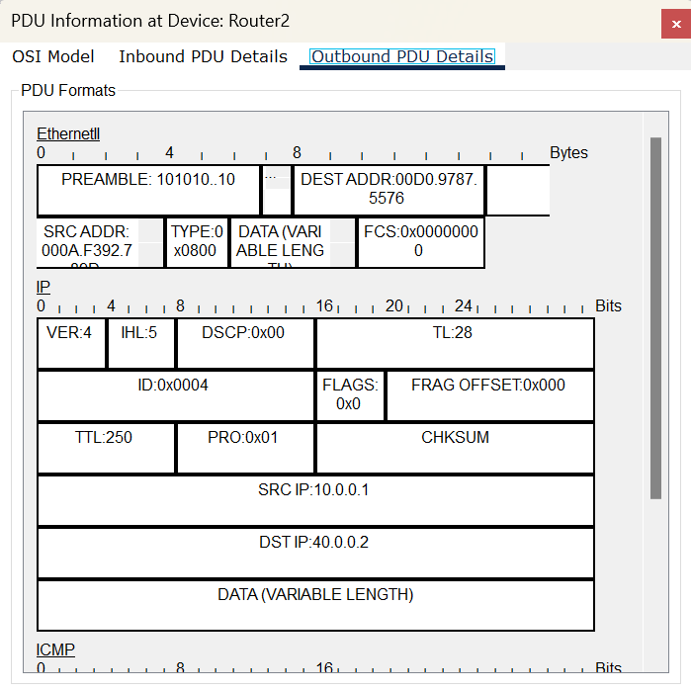

Figure 6.6: Outbound PDU, Router2



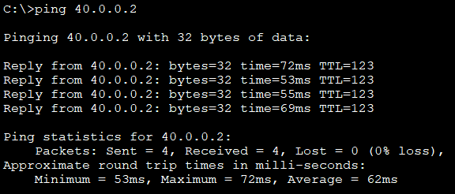

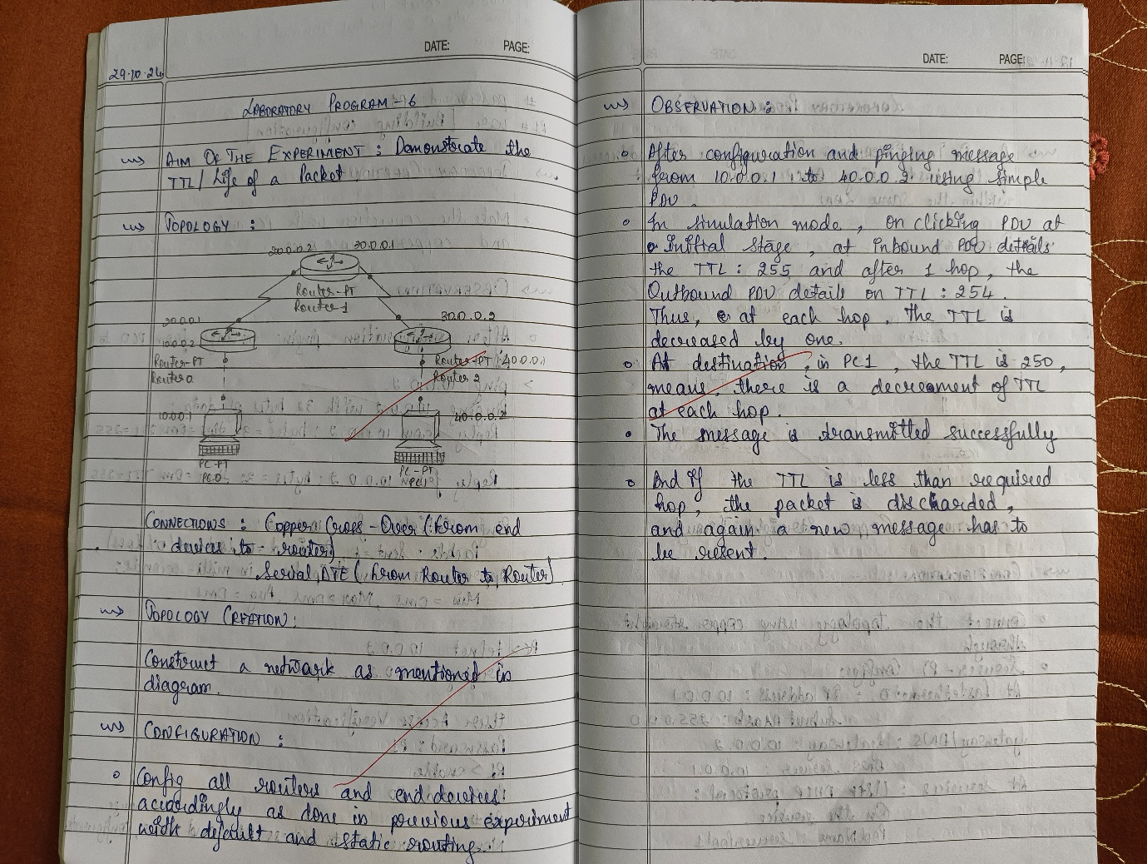

**LABORATORY PROGRAM – 7(A)**

To Configure IP addresses of the host using DHCP server within a LAN.

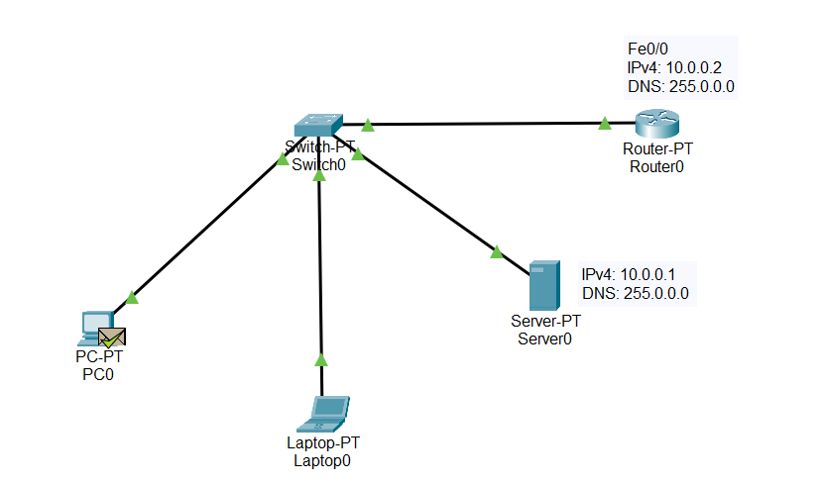

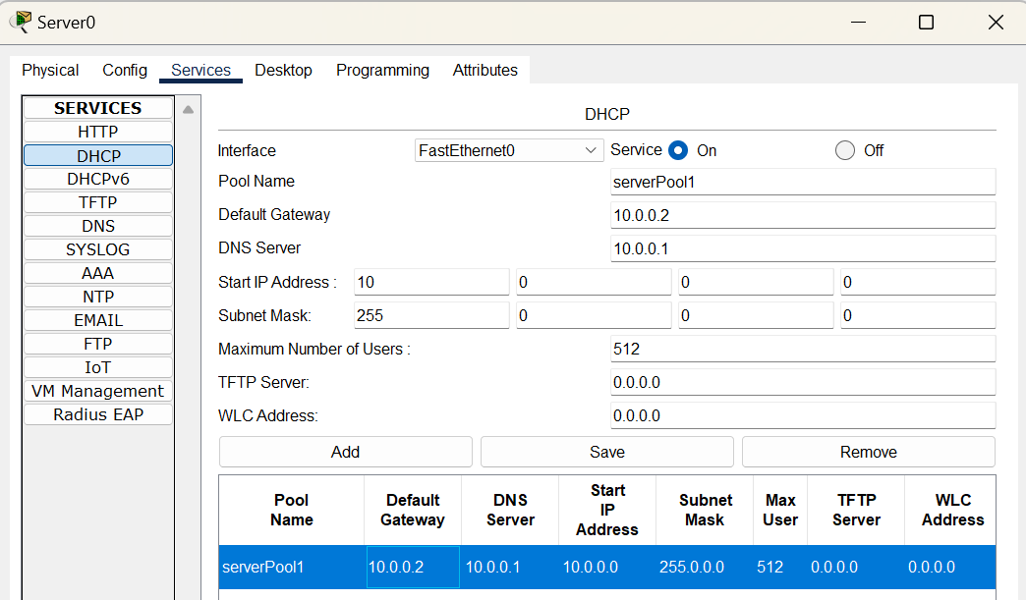

Figure 7.1: DHCP Service, Server0

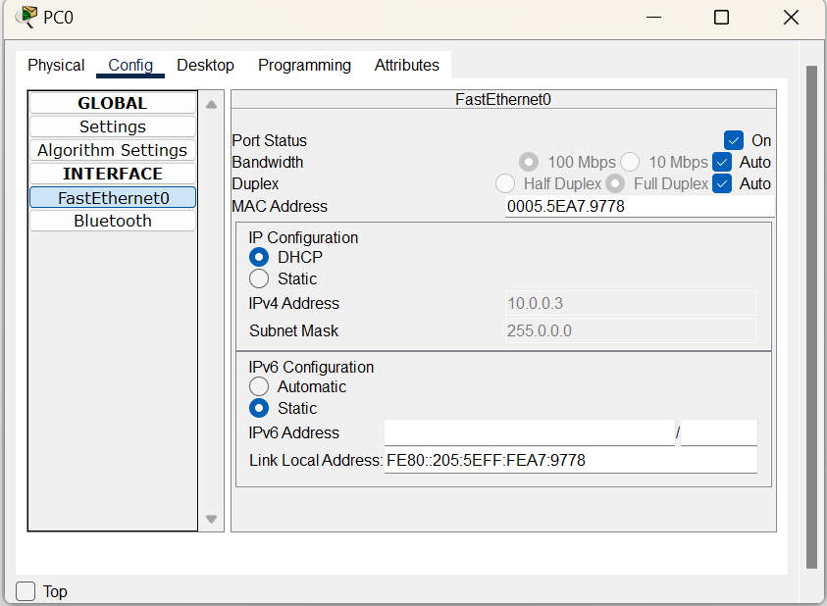

Figure 7.2: DHCP Service, PC0

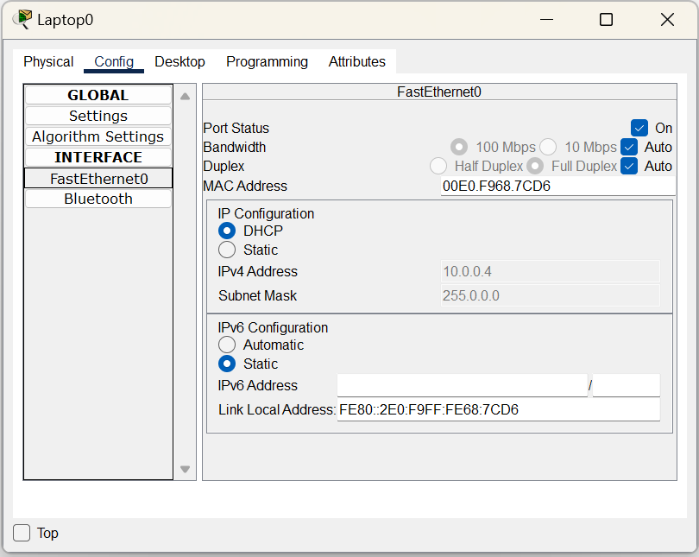

Figure 7.3: DHCP Service, Laptop0



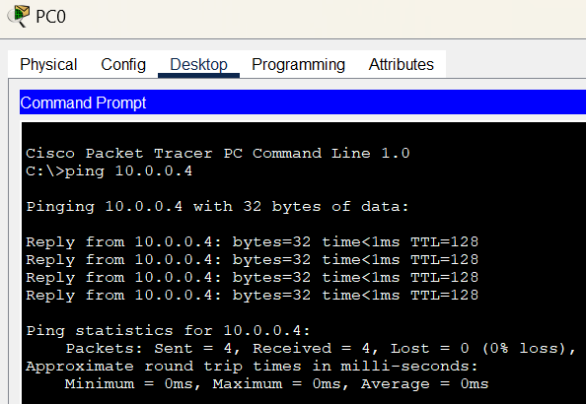

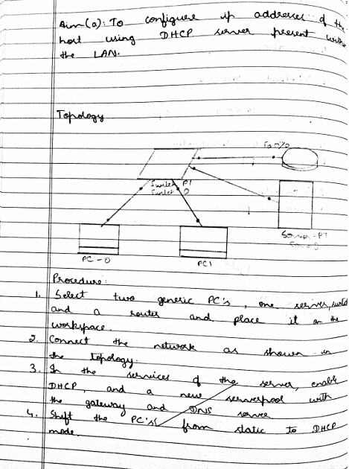

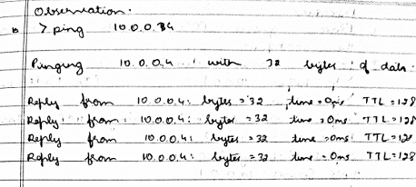

**LABORATORY PROGRAM – 7(B)**

To Configure IP addresses of the host using DHCP server outside a LAN.

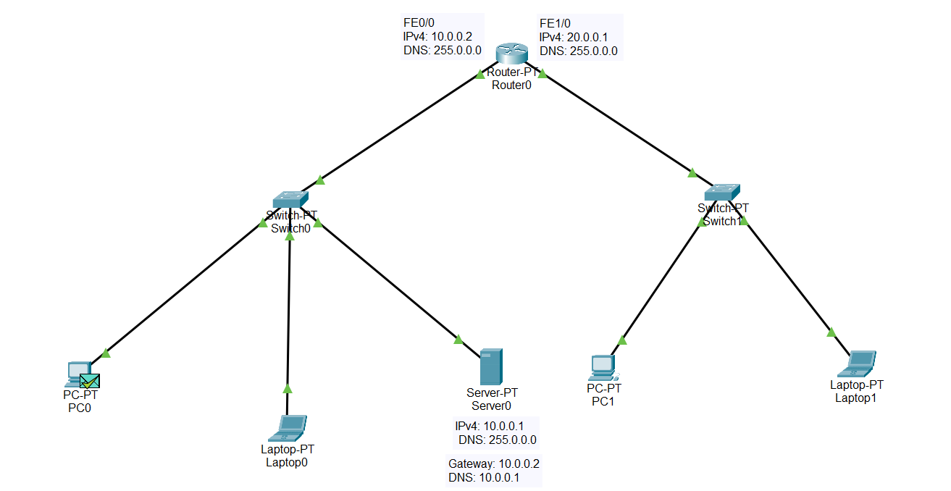

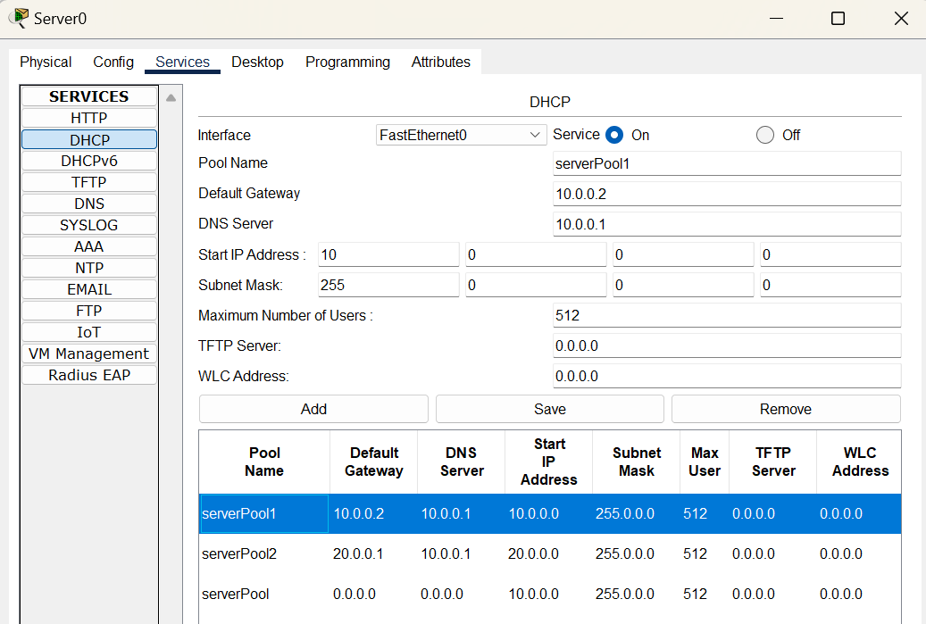

Figure 7..1: DHCP Service, Server0

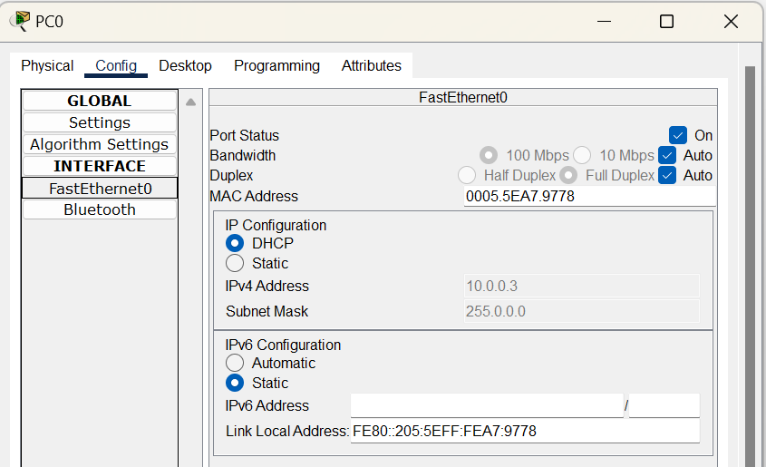

Figure7.2.2: DHCP Service, PC0

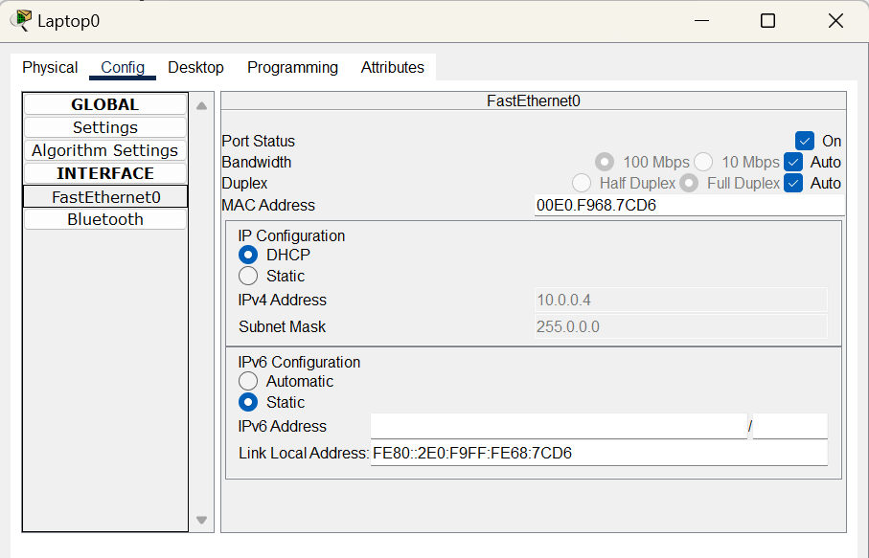

Figure 7.2.3: DHCP Service, Laptop0

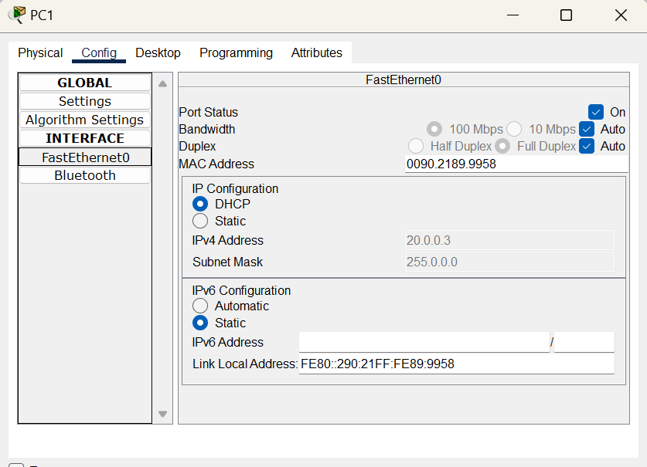

Figure 7.2.4: DHCP Service, PC1

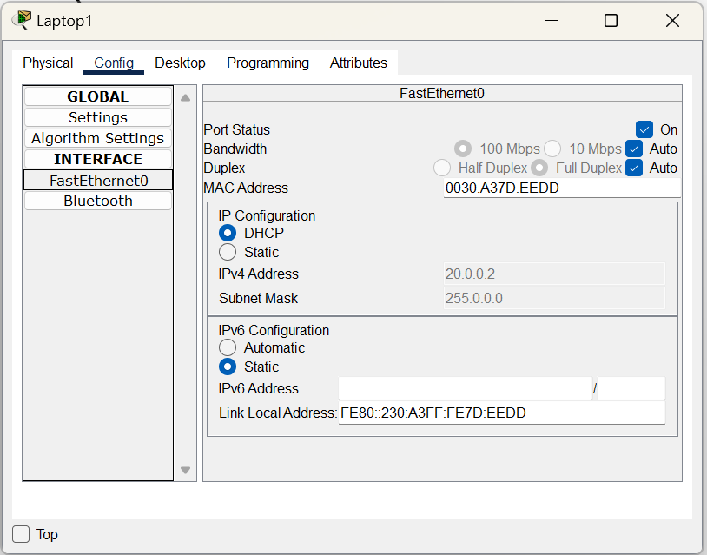

Figure 7.2.5: DHCP Service, Laptop1



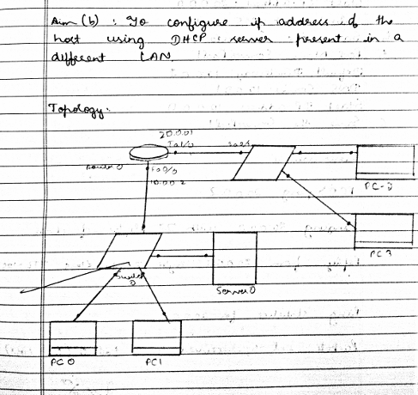

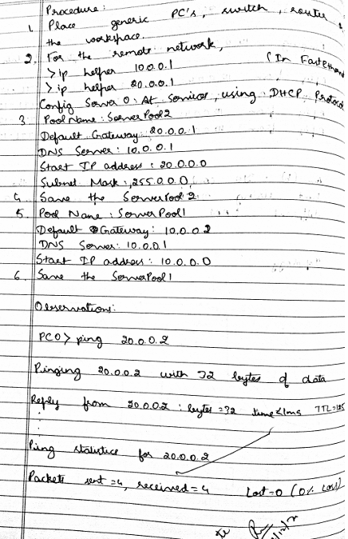

**LABORATORY PROGRAM – 8**

To Configure DNS server to demonstrate the mapping of IP addresses and Domain names.

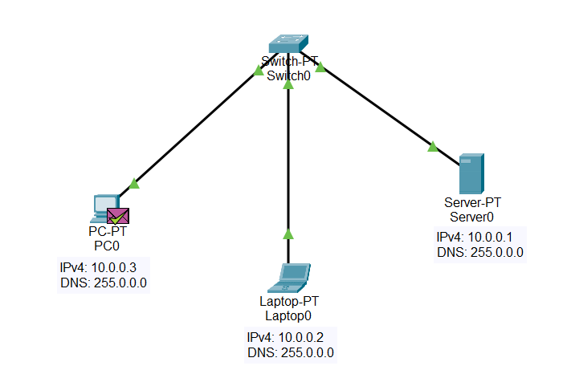

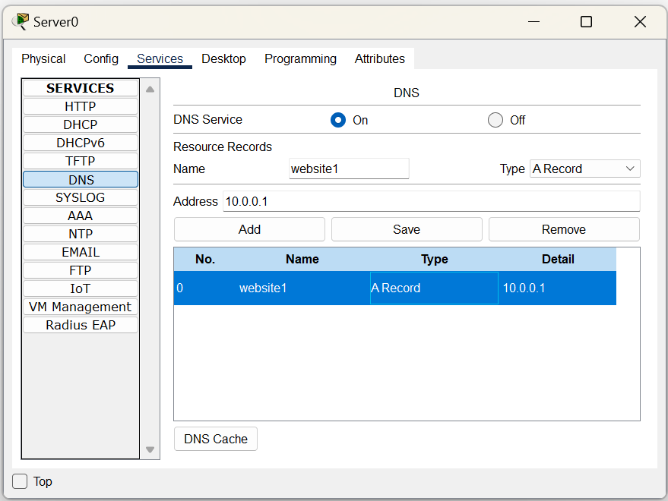

Figure 8.1: DNS Service, Server0

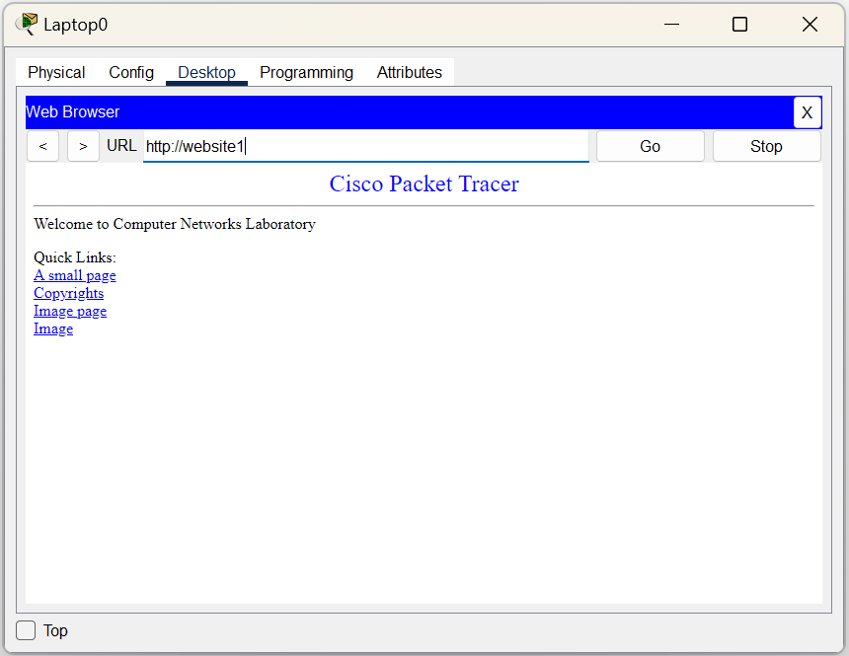

Figure 8.2: DNS Service, Laptop0

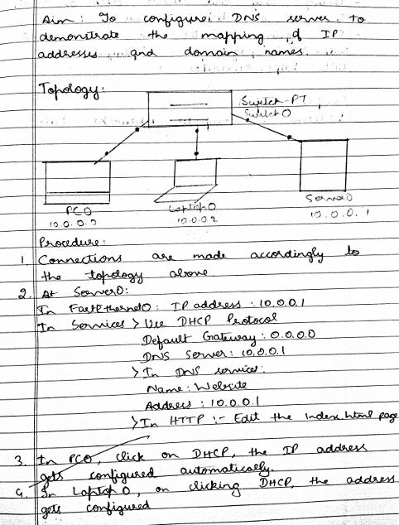

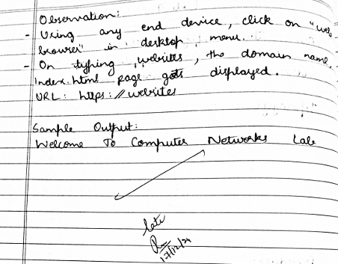

**LABORATORY PROGRAM – 9**

To Configure RIP routing protocol in Routers.

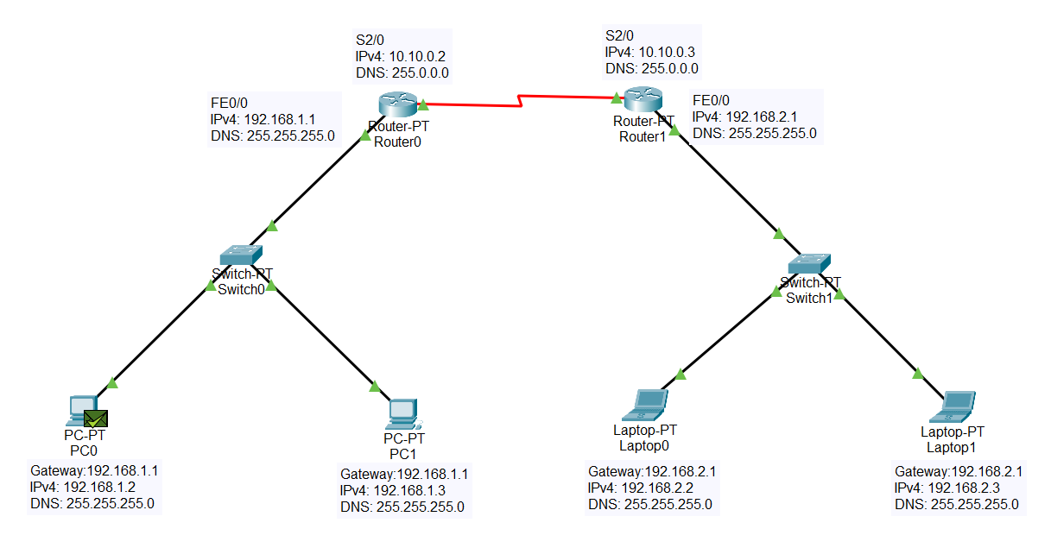

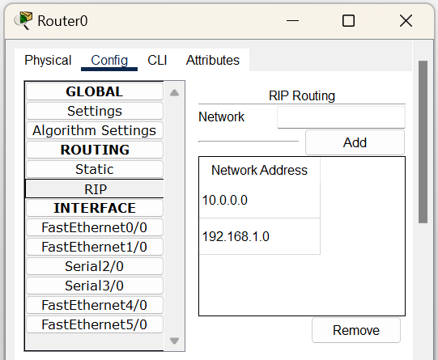

Figure 9.1: RIP, Router0

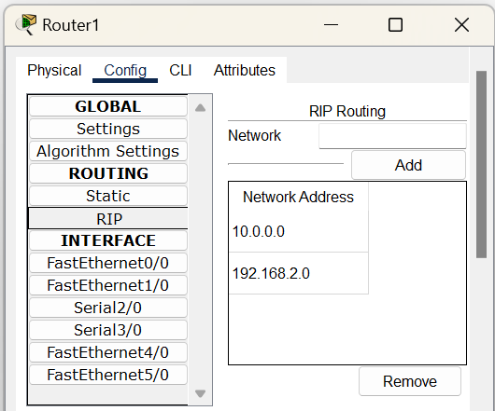

Figure 9.2: RIP, Router



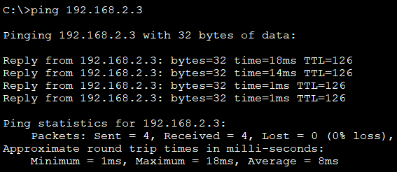

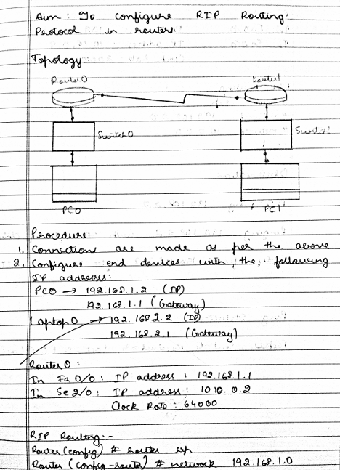

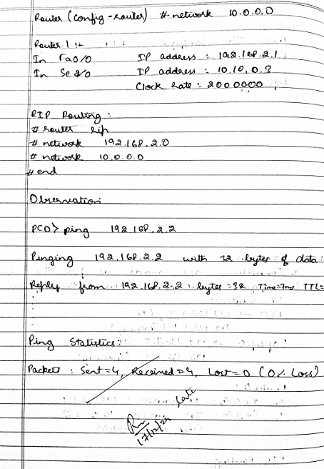

**LABORATORY PROGRAM – 10**

To demonstrate communication between two devices using a wireless LAN.

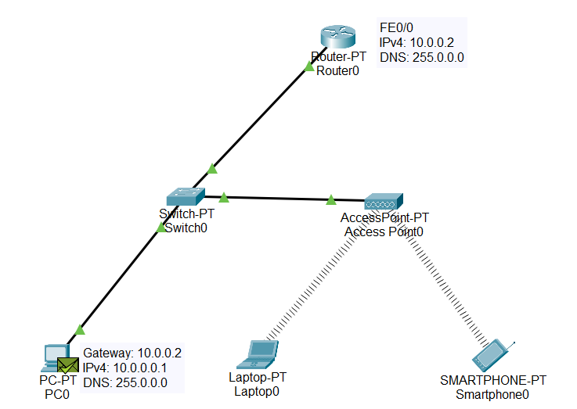

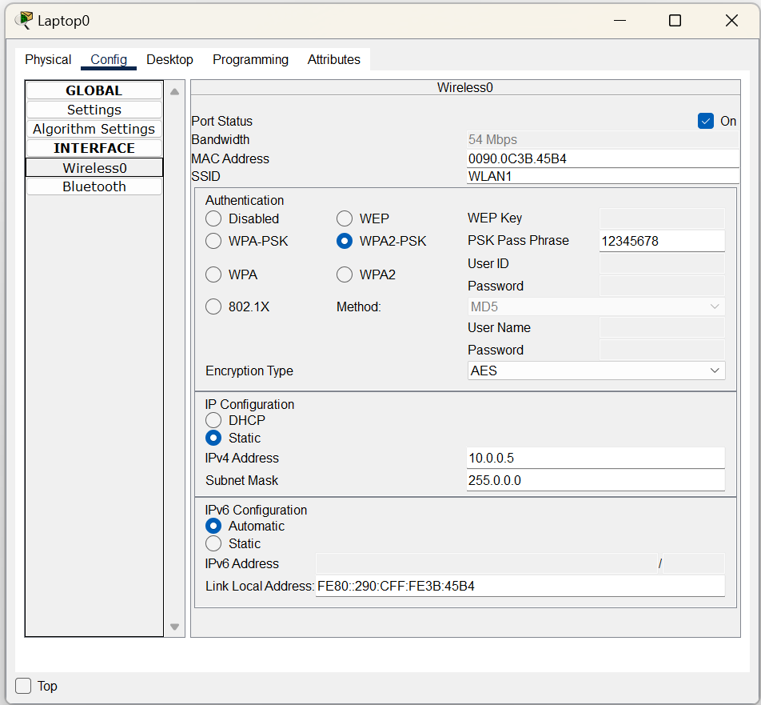

Figure 10.1: Laptop0, Wireless0

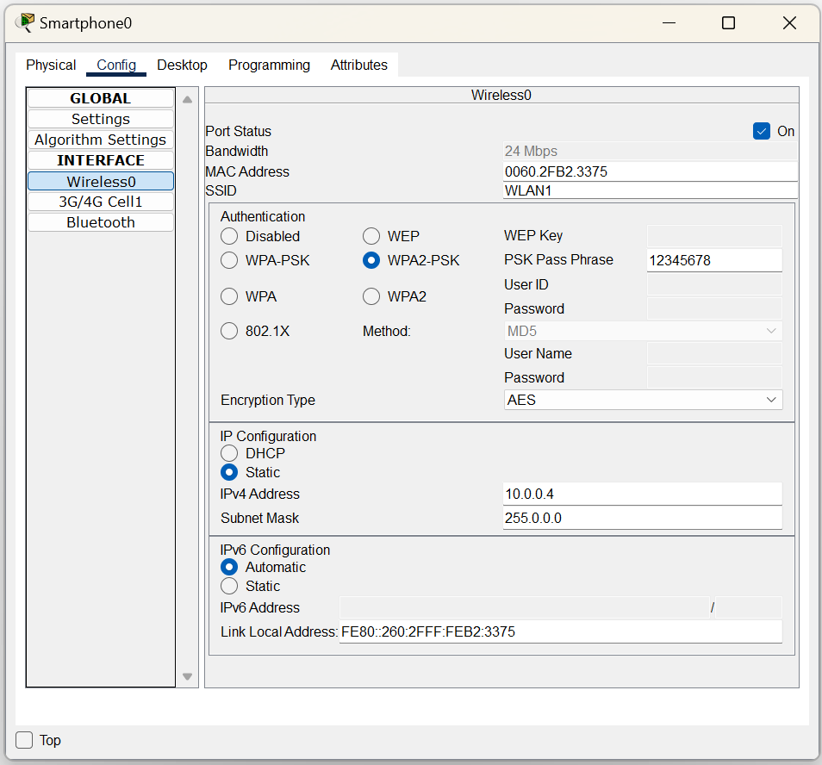

Figure 10.2: Smartphone0, Wireless0



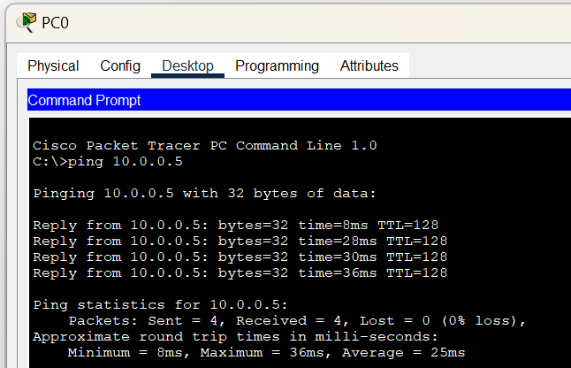

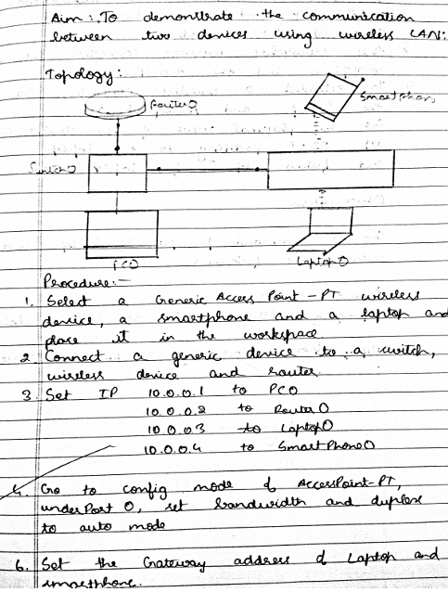

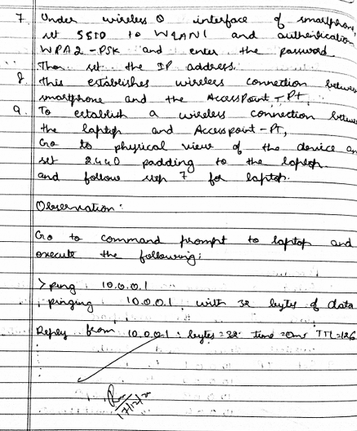

**LABORATORY PROGRAM – 11**

To demonstrate the working of Address Resolution Protocol (ARP) within a LAN for communication.

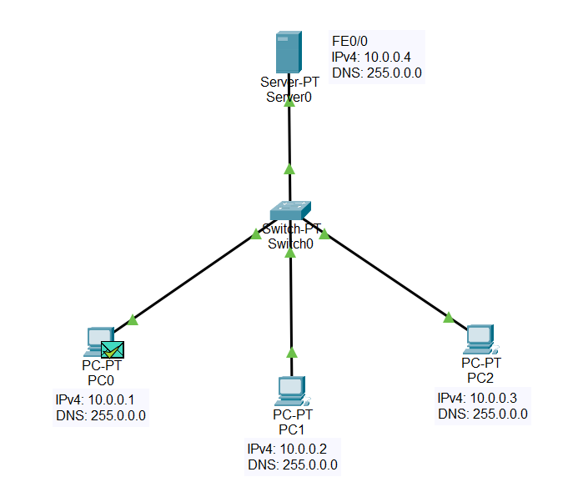

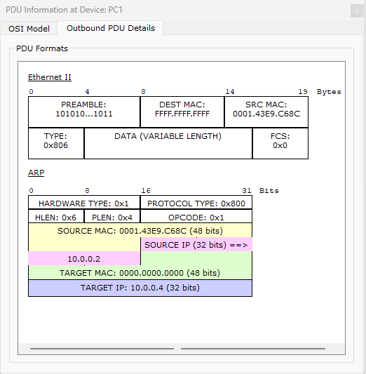

Figure 11.1: Inbound ARP, PC1

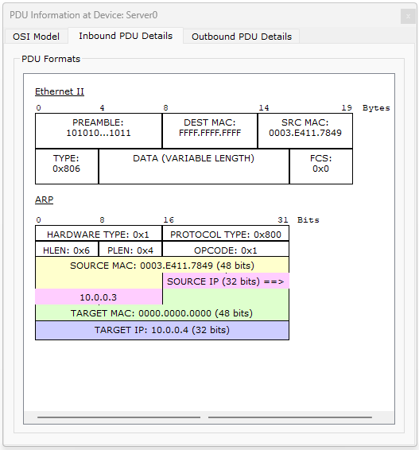

Figure 11.2: Inbound ARP, Server0

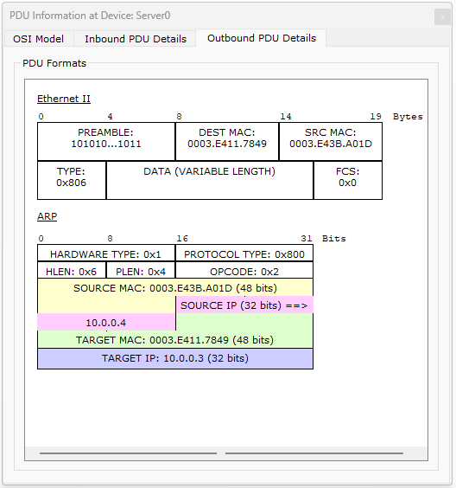

Figure 11.3: Outbound ARP, Server0

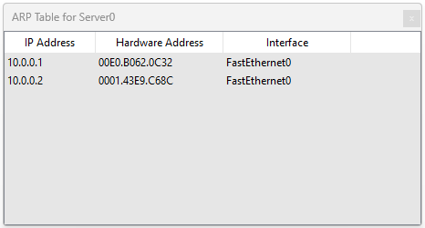

Figure 11.4: ARP Table, Server0

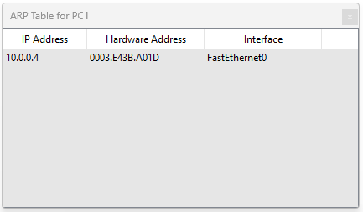

Figure 11.5: ARP Table, PC1



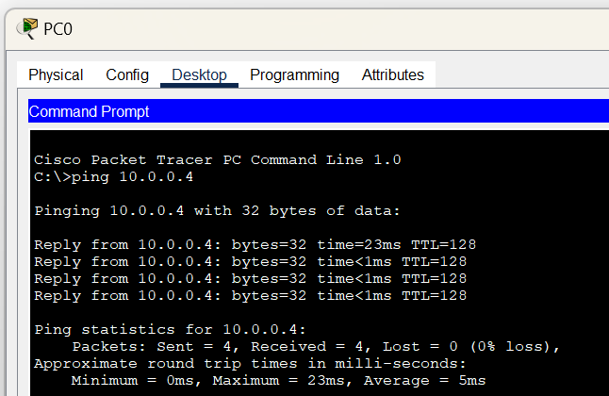

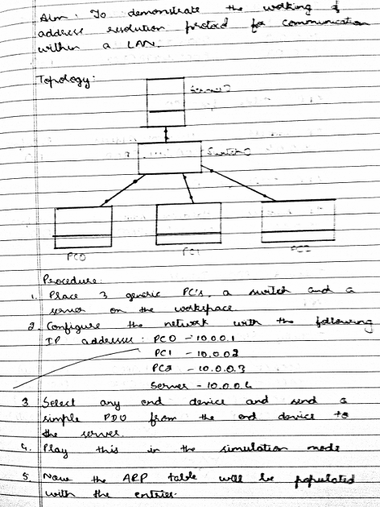

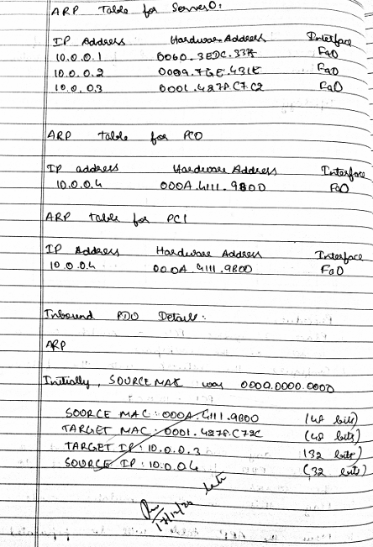

**LABORATORY PROGRAM – 12**

To create a VLAN on top of the physical LAN and enable communication between physical LAN and virtual LAN.

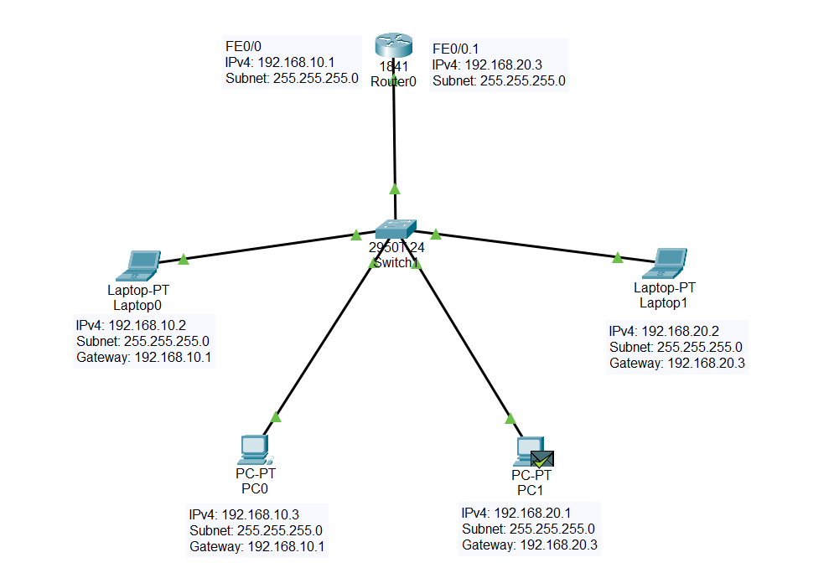

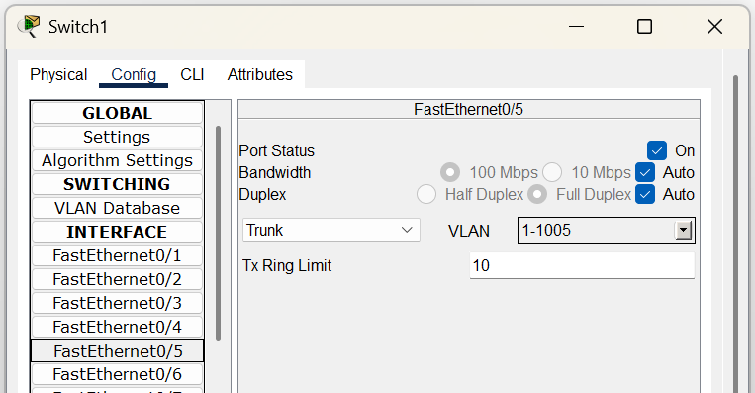

Figure 12.1: FE0/5 Switchport Trunk

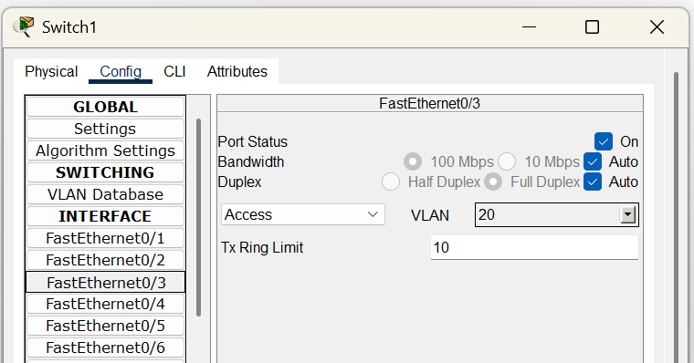

Figure 12.2: FE0/3 Switchport Access

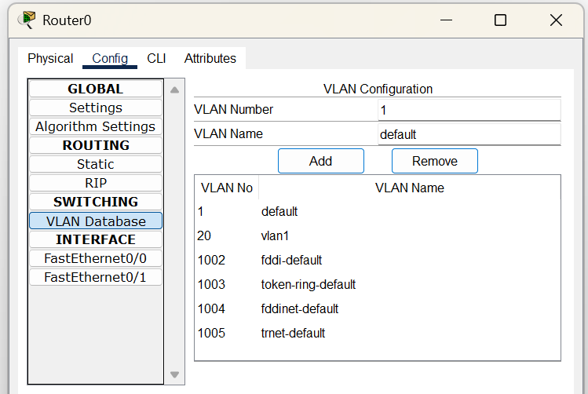

Figure 12.3: Router0 VLAN Database

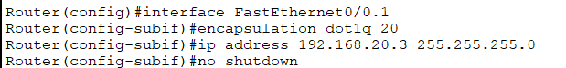

Figure : Router0, FE0/0.1



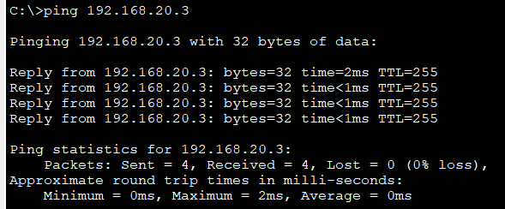

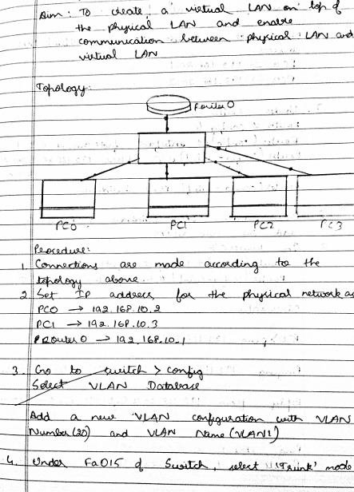

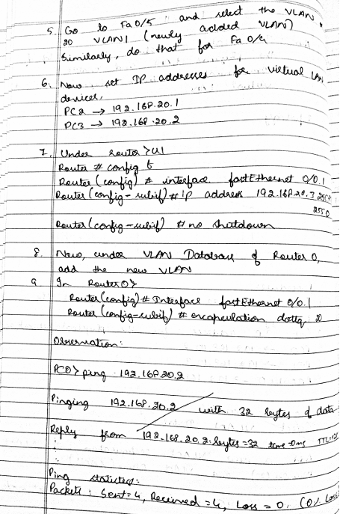

**LABORATORY PROGRAM – 13**

Write a program for error detecting code using CRC-CCITT (8-bits).

**Code**

def xor(dividend, divisor):

    """Perform XOR operation between dividend and divisor."""

    result = ''

    for i in range(1, len(divisor)):

        result += '0' if dividend[i] == divisor[i] else '1'

    return result

def crc(data, gen_poly):

    """Compute the CRC check value using CRC-CCITT (8-bit)."""

    data_length = len(data)

    gen_length = len(gen_poly)

    # Append n-1 zeros to the data

    padded_data = data + '0' * (gen_length - 1)

    check_value = padded_data[:gen_length]

    for i in range(data_length):

        if check_value[0] == '1':

            # XOR operation if the first bit is 1

            check_value = xor(check_value, gen_poly)

        else:

            # Retain original check value if first bit is 0

            check_value = check_value[1:]

        # Shift left and add the next data bit

        if i + gen_length < len(padded_data):

            check_value += padded_data[i + gen_length]

    return check_value[1:]  # Remove the leading bit

def receiver(data, gen_poly):

    """Simulate the receiver side to check for errors."""

    print("\n-----------------------------")

    print("Data received:", data)

    # Perform CRC computation on received data

    remainder = crc(data, gen_poly)

    # Check if the remainder is all zeros

    if '1' in remainder:

        print("Error detected")

    else:

        print("No error detected")

if __name__ == "__main__":

    # Input data and generator polynomial

    data = input("Enter data to be transmitted: ")

    gen_poly = input("Enter the Generating polynomial: ")

    # Compute CRC check value

    check_value = crc(data, gen_poly)

    print("\n----------------------------------------")

    print("Data padded with n-1 zeros:", data + '0' * (len(gen_poly) - 1))

    print("CRC or Check value is:", check_value)

    # Append check value to data for transmission

    transmitted_data = data + check_value

    print("Final data to be sent:", transmitted_data)

    print("----------------------------------------\n")

    # Simulate the receiver side

    received_data = input("Enter the received data: ")

    receiver(received_data, gen_poly)

**Output**

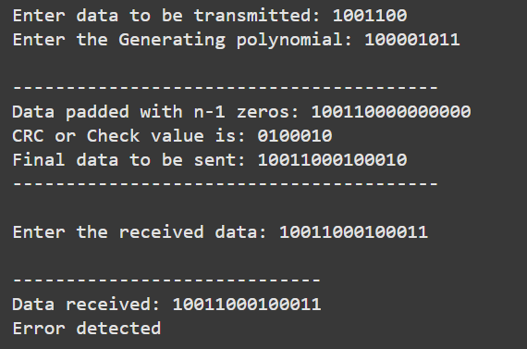

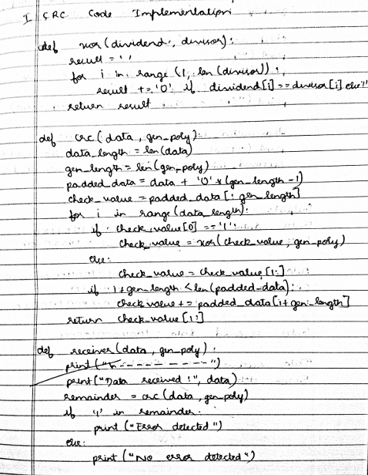

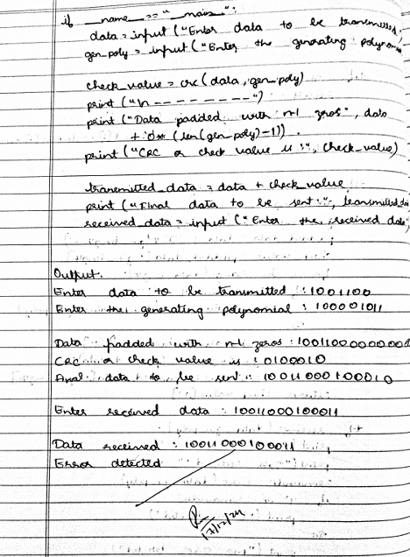

**LABORATORY PROGRAM – 14**

Write a program for congestion control using Leaky bucket algorithm.

**Code**

# Getting user inputs

storage = int(input("Enter initial packets in the bucket: "))

no_of_queries = int(input("Enter total no. of times bucket content is checked: "))

bucket_size = int(input("Enter total no. of packets that can be accommodated in the bucket: "))

input_pkt_size = int(input("Enter no. of packets that enters the bucket at a time: "))

output_pkt_size = int(input("Enter no. of packets that exits the bucket at a time: "))

for i in range(no_of_queries): # space left

size_left = bucket_size - storage

if input_pkt_size <= size_left:

# update storage

storage += input_pkt_size

else:

print("Packet loss =", input_pkt_size)

print(f"Buffer size = {storage} out of bucket size = {bucket_size}")

# as packets are sent out into the network, the size of the storage decreases

storage -= output_pkt_size

**Output**

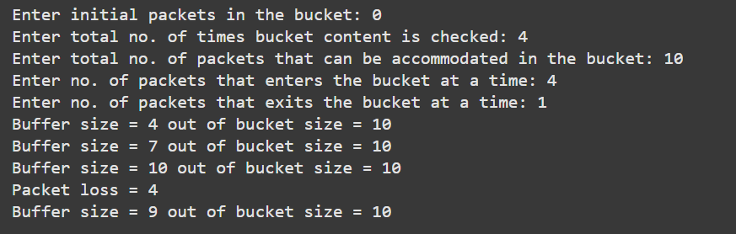

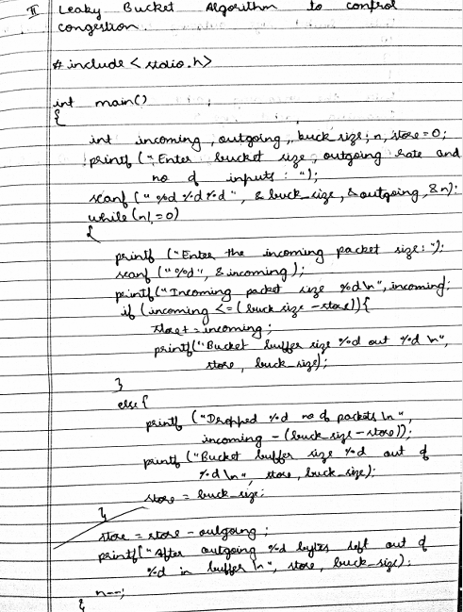

**LABORATORY PROGRAM – 15(A)**

Using TCP/IP sockets, write a client-server program to make client sending the file name and the server to send back the contents of the requested file if present.

**Code: Client.py**

from socket import *

serverName = "127.0.0.1" # Server address (localhost)

serverPort = 12000 # Port number where the server listens

# Create TCP socket

clientSocket = socket(AF_INET, SOCK_STREAM)

clientSocket.connect((serverName, serverPort)) # Connect to server

# Ask user for file name to request

sentence = input("Enter file name: ")

# Send file name to server

clientSocket.send(sentence.encode())

# Receive file contents from server

filecontents = clientSocket.recv(1024).decode()

print('From Server:', filecontents)

# Close the connection

clientSocket.close()

**Code: Server.py**

from socket import *

serverName = "127.0.0.1" # Server address (localhost)

serverPort = 12000 # Port number to listen on

# Create TCP socket

serverSocket = socket(AF_INET, SOCK_STREAM)

serverSocket.bind((serverName, serverPort)) # Bind socket to the address and port

serverSocket.listen(1) # Listen for 1 connection

print("The server is ready to receive")

while True:

# Accept a connection

connectionSocket, addr = serverSocket.accept()

# Receive the file name from the client

sentence = connectionSocket.recv(1024).decode()

# Try opening the file

try:

file = open(sentence, "r") # Open file in read mode

fileContents = file.read(1024) # Read file content (up to 1024 bytes)

connectionSocket.send(fileContents.encode()) # Send file contents to client

file.close()

except FileNotFoundError:

# Send error message if file not found

connectionSocket.send("File not found".encode())

# Close the connection

connectionSocket.close()

**Output**

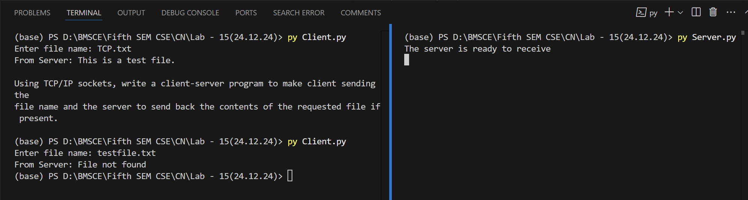

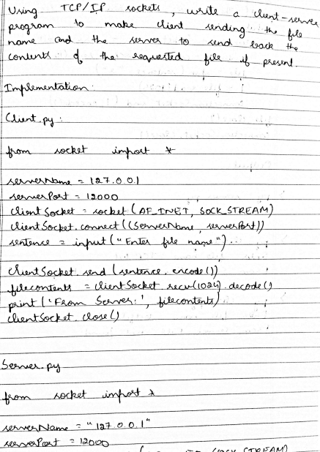 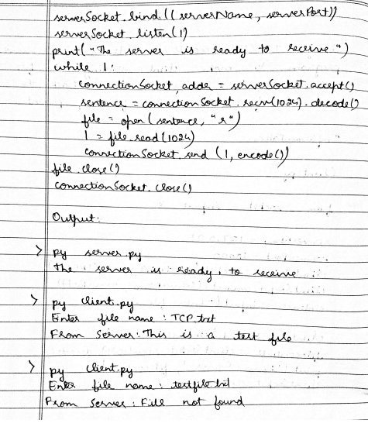

**LABORATORY PROGRAM – 15(B)**

Using UDP sockets, write a client-server program to make client sending the file name and the server to send back the contents of the requested file if present.

**Code: ClientUDP.py**

from socket import *

serverName = "127.0.0.1" # Server address (localhost)

serverPort = 12000 # Port number where the server listens

# Create UDP socket

clientSocket = socket(AF_INET, SOCK_DGRAM)

# Ask user for file name to request

sentence = input("Enter file name: ")

# Send the file name to the server using UDP

clientSocket.sendto(sentence.encode("utf-8"), (serverName, serverPort))

# Receive file contents from the server

fileContents, serverAddress = clientSocket.recvfrom(2048)

# Print the file contents received from the server

print("From Server:", fileContents.decode())

# Close the UDP socket

clientSocket.close()

**Code: ServerUDP.py**

from socket import *

serverPort = 12000 # Port number to listen on

# Create UDP socket

serverSocket = socket(AF_INET, SOCK_DGRAM)

serverSocket.bind(("127.0.0.1", serverPort)) # Bind the socket to the server address and port

print("The server is ready to receive")

while True:

# Receive file name from the client

sentence, clientAddress = serverSocket.recvfrom(2048)

# Try opening the file

try:

file = open(sentence.decode(), "r") # Open file in read mode

fileContents = file.read(2048) # Read file content (up to 2048 bytes)

serverSocket.sendto(fileContents.encode("utf-8"), clientAddress) # Send file contents to client

file.close()

except FileNotFoundError:

# Send error message if file not found

serverSocket.sendto("File not found".encode("utf-8"), clientAddress)

**Output**

